WEEK OF PRAYER
FOR CHRISTIAN UNITY – 2023

What is the Week of Prayer for Christian Unity?
With more than 100 years of history, this annual observance involves Christian communities throughout the world. Its current form arose in 1968 from an initiative organised by the Faith and Order Commission of the World Council of Churches and the Roman Catholic Pontifical Council for Christian Unity. The Week of Prayer for Christian Unity is offered to take time to listen and hear from sister churches and fellow Christians in diverse parts of the world that take turn in preparing the theme and material.

The traditional observance of the Week of Prayer for Christian Unity in Aotearoa New Zealand is between Ascension and Pentecost (in the Northern Hemisphere it us usually observed in late January between the feast days of St’s Peter and Paul).

Please consider organising a local observance, maybe through a combined service, or other shared activities and prayer:
A combined ecumenical service of neighbouring churches held one evening during the week.
A combined social event or meal
A combined initiative for a local issue (such as a beach clean or community garden planting)
Commit with local churches to incorporate a prayer within respective Sunday services; praying for each other’s churches, and praying for ecumenical unity.
Commit to a prayer relay – where for each day during the week, a different church community commits to joining the prayer for Christian unity, for each other’s ministries, and the communities in your town/city/region are served.

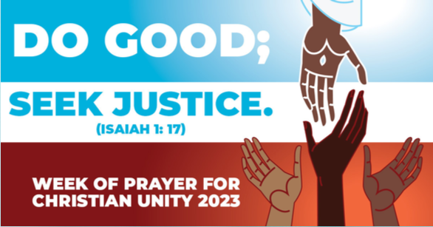
The theme for 2023: Do good, seek justice
The international resources are prepared by the World Council of Churches and the Vatican, and each year supported by a local workgroup of churches. The materials for 2023 have been prepared with the churches in Minneapolis, the US city in which George Floyd was murdered in 2020. The text chosen is Isaiah 1:12-18, and the focus verse is Isaiah 1:17 to give the theme of Do good; seek justice.

The Week of Prayer is the perfect time for Christians to recognize that the divisions between our churches and confessions cannot be separated from the divisions within the wider human family. Learning to do right requires the decision to engage in self-reflection. Praying together for Christian unity allows us to reflect on what unites us and to commit ourselves to confront oppression and division amongst humanity.

Praying for unity amidst injustice can explore how the work of Christian unity can contribute to the promotion of racial justice across all levels of society.

Rev. Dr Curtiss Paul DeYoung, co-chief executive officer of the Minnesota Council of Churches, was involved in preparation of this year’s Week of Prayer for Christian Unity materials. In a recent interview with the WCC, he offered these reflections, which may help inspire local adaptations for Aotearoa New Zealand.
What were the biggest challenges the authors faced in drafting this year’s materials for the Week of Prayer for Christian Unity?
The work of composing the materials was very personal for the team of authors. We organized a team with a majority of Black voices, yet included others who were engaged. The 2023 resources were designed by a team of six Black, two Indigenous, and one Latine Christian leaders in Minnesota. All equally contributed in the writing and editing.
They all had direct experience with racism, intense feelings of grief and outrage at the killing of George Floyd in Minneapolis, and subsequent involvement in the protests that resulted. Engaging scriptural texts to call for racial justice and unity required revisiting the very personal nature of the work. Another challenge was selecting language that would convey a Minneapolis or United States perspective of racism in a way that could be understood by a global audience. A third challenge was how to speak to an institutional church that contains both those in power and those who feel powerless. Calling for Christian unity requires a balance of both a prophetic and pastoral approach that acknowledges complicity and offers healing.

For people that would term some of your resources “political” rather than “spiritual,” what would you say to them?
Issues of racial and social justice cannot easily be divided between political or spiritual. The Hebrew prophets often spoke truth about injustices to the political leaders of their time. Jesus preached a gospel that was good news and liberation to those oppressed. The spiritual is political; and the political needs the spiritual.

What is your personal hope for the Week of Prayer for Christian Unity?
I hope that this resource created by a team of Minnesota Christian leaders will motivate Christians around the world to address the injustices in their context that divide society and the church. This begins with dialogue that creates a biblically-informed shared understanding and is followed by a commitment to the long haul.

Resources:
A key resource offered is a liturgy for an ecumenical service which allows for local adaptation.

Attached is a version for Aotearoa New Zealand. Based on the international liturgy, it has been adapted by a Wellington-based ecumenical workgroup co-ordinated through the National Dialogue for Christian Unity for Aotearoa New Zealand. Further local adaptation may be made to the text, add or substitute prayers or litanies, choosing your own hymns and songs, or incorporating actions and expressions in the worship; so as to add local relevance to the international theme.

Within the international resource booklet there is a further optional resource of daily readings, reflections and prayers for each day through the week of observance.

See also https://www.oikoumene.org/resources/week-of-prayer-for-christian-unity

Rev. Tony Franklin-Ross
Secretary for the National Dialogue for Christian Unity for Aotearoa New Zealand
Contact – tonyfr@methodist.org.nz

